Sergio Araneda, Ph.D.
sondaxius@gmail.com

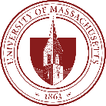 | Ph.D., Research, Educational Measurement, and Psychometrics  University of Massachusetts Amherst 2019 - 2022
 | Mathematical Civil Engineer  Universidad de Chile 2005 – 2013  A mathematical civil engineer has 2 years in a common program with the rest of other engineering programs and 4 years of specific training in modern mathematics: Functional analysis, Measure theory, Partial Differential Equations, Stochastic processes, Optimization (linear, non-linear, discrete, optimal control), Discrete Mathematics, Numerical Methods, Information theory, and Statistics. It’s a strong program, one of the most prestigious programs in Applied Math in Latin America.

Work Experience

Research Scientist, Caveon; July 2023 – Present (1Y 8M)  Remote, done from New York City, NY, US  General work on research topics of relevance for Caveon, including the use of Large Language Models (LLM) in combination with Caveon’s technologies like SmartItems™. Participation in conferences and Collaboration with members of the company doing Research and preparing papers. | 
Associate Psychometrician, College Board; October 2022 – April 2023 (7M)  Remote, done from New York City, NY, US  I participated in the work of the PsyTech Team in the Psychometrics division at College Board. Part of my duties corresponded to Research related to Item Parameter Drift and Automatic Essay Scoring for the SAT Essay test. | 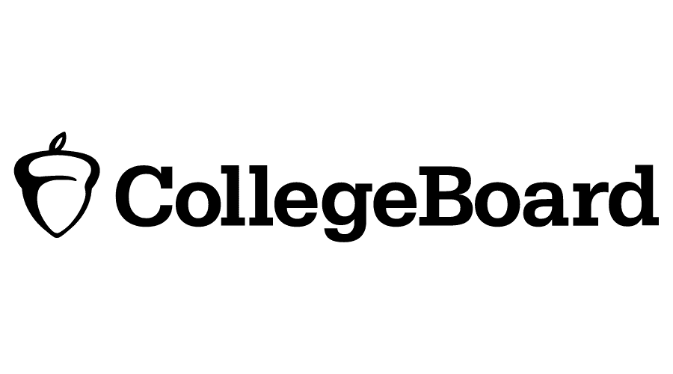
Research Assistant, Departamento de Medición y Registro Educacional (DEMRE); August 2017 – December 2018 (1Y 4M)  In-person Santiago, Chile; and Remote, done from Jersey City, NJ, US  DEMRE is a department under Universidad de Chile that specializes in educational measurement. It is responsible for designing the Prueba de Selección Universitaria (PSU), the exam used for college admissions in Chile. I worked as a research assistant in a project evaluating the use of one score named “ranking de notas” in the Chilean admission system. | 

Internships

Caveon, March 2022 – August 2022  Remote, done from Amherst, MA, US  I worked constructing “Smart-items,” a technology developed by the company for Automatic Item Generation. I used my programming skills to create Smart-items of different types. I used Natural Language Processing as well to generate Correct-Incorrect statements automatically from a text. | 
ETS AI Labs, June 2021 – August 2021  Remote, done from Amherst, MA, US  I worked as a summer intern in one of the projects of the AI labs at ETS, an app named “Authentic,” made to help early career professionals to improve their interview skills. My role in the agile team was to provide a logic for feedback generation for audio cues in an interview, specifically using filler words and effective uses of pauses. | 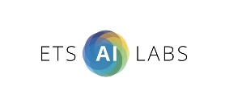

Other previous experiences in Finances

Datamart Murex Consultant, CPQi; August 2018 – July 2019  In-person Jersey City, NJ, US  Working as an external consultant for RBC (Royal Bank of Canada) in a Murex implementation project for Rates and their internal reports. The work required intensive SQL programming and proficiency in Murex, a software used in the finance industry for derivatives management. | 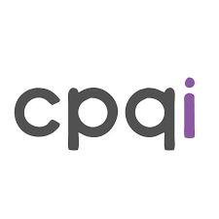
Back-Office Functional Consultant, Murex; September 2014 – February 2017  In-person Santiago, Chile  Murex is a French software company that created the software MX.3, a platform financial institutions use to support the operation of financial products such as derivatives. My role on this job was to support clients in the Andean region on the functionalities related to the Back-office MX.3 provides. Most of my work was related to Post-trade workflow, Accounting, Confirmation documents, Settlement, Netting, pre-trade, and reporting (for Back-Office purposes). | 
Quantitative Analyst, Vision advisors; September 2013 – August 2014  In-person Santiago, Chile  I worked as an analyst doing reports for institutional clients of our office, mostly related to investment recommendations and regulatory requirements. | 

Technical Skills & Languages
 | Python | Working with Python since 2013.  Machine learning Pytorch.
 | R | Working with R since 2018.
 | Other scripting languages | SQL, MATLAB, Java, XML, XSL, UNIX, Stata, Git.
 | Psychometric & Statistical Software | FlexMIRT, MPlus.
 | Optimization Software | Gurobi, Cplex.

 | English | Advanced reading level, Advanced oral level, Advanced writing level. TOEFL iBT score 102/120
 | French | Advanced reading level, Intermediate oral level, Intermediate writing level.
 | Spanish | Native Language.

Teaching Experience

Created Courses
First Year Seminar (FYS) Principles of game design applied in Education, Fall 2021  College of Education, University of Massachusetts Amherst  This course covers core principles of game design, focusing on best practices and methodologies for creating engaging and effective games. Emphasis is placed on the application of game design concepts in educational contexts, enabling students to explore how game mechanics and design principles can enhance learning experiences. | 
Teaching Assistant (TA)
Probability and Statistics, Fall 2012  Facultad de Ciencias Físicas y Matemáticas, Universidad de Chile  This course covers introductory topics to probability, and some initial topics related to statistics. | 
Mathematical Reasoning in Elementary School, Fall 2011  Facultad de Ciencias Físicas y Matemáticas, Universidad de Chile  This course covers an introduction to the concept of mathematical reasoning and its applications in the classroom for K-12 math teaching. | 
Linear Algebra, Fall 2008  Facultad de Ciencias Físicas y Matemáticas, Universidad de Chile  This course covers an introduction to linear algebra for engineering students. | 
Volunteer work and public engagement

Committee member, Diversity Issues in Testing Committee (CODIT)  May 2024 – April 2025  I am a member of the Diversity Issues in Testing Committee (CODIT) at NCME. I serve as a reviewer of some assignments specific of the committee. | 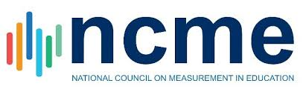
Chair, NCME Graduate Student Issues Committee (GSIC).  July 2021 – May 2023  I was one of the chairs of the NCME Graduate student issues committee (GSIC). This committee is in charge of raising the concerns and voices of graduate students to the NCME board and organizing social events for the graduate students. I led different types of activities, with great evaluation from the NCME board during my term as a Senior Chair in the annual conference in Chicago (2023). | 
Coordinator, NCME-GSIC Standards study group & Statement New Edition of the Standards  October 2021 – April 2023  I led a study group focusing on the current version of the Standards, doing a series of discussions among students and Q&A sessions with experts. In the second stage of the study group, we wrote a statement about the new Edition of the Standards with our position as a generation. Find more info about the Standards Study Group here. | 
Coordinator, FEVED Foro chileno de profesionales en evaluación educacional (Chilean Forum of professionals in educational assessment).  September 2020 – August 2021  I organized a group of young Chilean professionals in educational assessment to create some space of debate and public engagement in relevant assessment topics in our country. We meet regularly once a month, I was their first coordinator. More info (in Spanish) www.feved.cl | 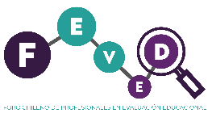

Publications

Peer Reviewed Journals

Araneda, S., Fremer, J., & Foster, D. (2024). Commentary: Past, Present, and Future of Educational Measurement. Educational Measurement: Issues and Practice. https://doi.org/10.1111/emip.12632 | 
Araneda, S., Lee, D., Lewis, J., Sireci. S. G., Moon, J. A., Lehman, B., Arslan, B., & Keehner, M. (2022). Exploring relationships among test takers’ behaviors and performance using response process data. Education Sciences. https://doi.org/10.3390/educsci12020104 | 

White papers & Dissertation

Araneda, S. (2023). AN EXPERIENTIAL APPROACH TO TEST DESIGN AND VALIDATION [Dissertation, University of Massachusetts Amherst]. Scholarworks@UMassAmherst. https://hdl.handle.net/20.500.14394/19086 | 
Araneda, S., Beiting-Parrish, M., Bottoms, B., La Torre, D., McIntee, K., Musa, S., Sarac, M., Qingzhou, S., Tolentino, L., Tufail, M. & Valdivia Medinaceli, M. (2023). Statement about the New Edition of the Standards for Educational & Psychological Testing [White paper]. https://doi.org/10.31235/osf.io/dv4pa | 
Araneda, S., Vargas, A. O., Chávez, C., de Padua, E., & Gándara, F. (2023). PAES y el futuro de las pruebas para la admisión universitaria en Chile: ¿son suficientes los cambios para un sistema de admisión equitativo? [White paper]. https://doi.org/10.31235/osf.io/jh642 | 

Newspapers

Araneda, S. (2024, January 9th) Ranking PAES sin interpretación. El Desconcierto. https://eldesconcierto.cl/2024/01/09/ranking-paes-sin-interpretacion | 
Araneda, S. (2023, January 8th) PAES y rankings. El Mercurio. | 
Araneda, S. (2022, December 1st) Fin a la PAES. La Tercera. | 
Araneda, S., Chavez, C., Fernández, MP., Gándara, F., Jimenez, F., Labarca, L., Osses Vargas, A., Zunino, V. (2022, July 14th) Pruebas PAES y Manual Técnico. La Tercera. | 
Araneda, S., de Padua, E., Gándara, F., Labarca, L., Osses Vargas, A., Villa, S., Zepeda, S., Zunino, V. (2022, July 3rd) Simce: una decisión errada. El Mercurio. | 
Araneda, S., Chavez, C., de Padua Nájera, E., Gándara, F., Jimenez, F. A., Osses, A., Zepeda, S., Zunino Edelsberg, V. (2021, April 19th) Vuelta atrás: reincorporación de Simce lectura 2º básico. La Tercera. | 
Araneda, S. (2021, August 1st) Los riesgos de la PDT en tiempos de Covid-19. El Desconcierto. https://www.eldesconcierto.cl/opinion/2021/01/08/los-riesgos-de-la-prueba-de-transicion-pdt-en-tiempos-de-covid-19.html | 

Presentations in Conferences

Organized Sessions

Araneda, S., Torres-Iribarra, D., Alarcón-Bustamante, E., Gonzalez-Wegener, X., Gándara, F., Fremer, J. (2024, July) College Admission in Chile: Inequity, Social Unrest, and More Testing [Symposium]. International Testing Commission bi-annual meeting, Granada. | 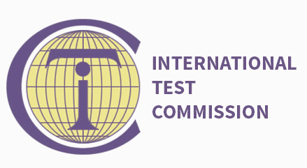
Araneda, S., Sarac, M., Beiting-Parrish, M., Valdivia Medinaceli, M. B., Huff, S. & Huff, K. (2023, April) GSIC Standards Study Group: Recommendations from Graduate Students for Its New Version [Paper Session]. National Council on Measurement in Education annual meeting, Chicago. | 

Panel Participation

Drane, W., Quesen, S., Araneda, S., Olson, J. (2024, October) Use of Generative AI in Secure Item Development for State Assessment Programs: Recommendations for Future Implementation by States [Panel Presentation]. Conference on Test Security, Salt Lake City. | 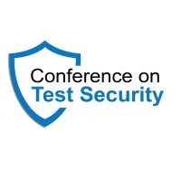
Chakraborty, R., & Jackson, J. A. (Chairs). (2023, April). Navigating job opportunities and preparing for job markets: Let's get ready together [Panel discussion]. Graduate Student Council Division D Fireside Chat, AERA 2023 Annual Meeting, InterContinental Chicago Magnificent Mile, Chicago, IL. Panelists: Boyd, B., Van Orman, D. S. J., Riley-Lepo, E., Araneda, S., & Choiseul-Praslin, B. D. | 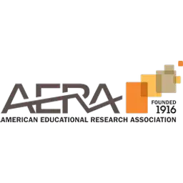

Individual Presentations

Araneda, S. (2024, October) Score-Difference-at-Risk (SDaR): Using Risk Metrics to Anticipate the Impact of Test Security Breaches. [Presentation]. Conference on Test Security, Salt Lake City. | 
Araneda, S., Colvin, K., O’Donnell, F., Padellaro, F., Wells, C. (2024, October) Prompt Engineering for Binary Response Item Generation Using ChatGPT. [Presentation]. Northeastern Educational Research Association Annual Meeting, Trumbull. | 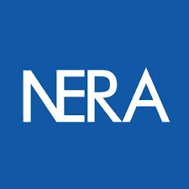
Araneda, S. (2024, July) Score-Difference-at-Risk (SDaR): Using risk metrics to anticipate negative impact. [Presentation]. IMPS, Praha. | 
Foster, C., Weaver, S. & Araneda, S. (2024, July) Using ChatGPT for Semi-Automatic Generation of Item for Summative Assessment: a Case Study [Presentation]. International Test Commission Bi-Annual Meeting, Granada. | 
Araneda, S., Sireci, S., Crespo-Cruz, E. & Mena-Serrano, F. (2024, July) A Conceptual Framework for Assessment Experience in Educational Testing [Presentation]. International Test Commission Bi-Annual Meeting, Granada. | 
Araneda, S. & Gonzalez-Wegener, X. (2024, July) Studying Test-Taker Experiences Shared on TikTok about Standardized Testing and College Admission in Chile [Presentation]. International Test Commission Bi-Annual Meeting, Granada. | 
Gándara, F. & Araneda, S. (2024, July) Change is never easy: the case of Chilean University admissions and their new battery of standardized tests PAES [Presentation]. International Test Commission Bi-Annual Meeting, Granada. | 
Foster, D., Foster, C., Marder, A. & Araneda, S. (2024, April) Evaluating the test security benefits of randomly parallel tests: protecting against pre-knowledge [Presentation]. National Council on Measurement in Education annual meeting, Philadelphia. https://youtu.be/A6fOUrriuK4 | 
Araneda, S. (2024, March) Comparing Humans, NLP models and LLMs to create binary response items. [Presentation]. Innovations in Testing, Association of Test Publishers, Anaheim. https://youtu.be/kl1XSzNrWWs | 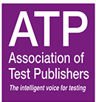
Araneda, S. (2022, April) Situating the validity argument: lessons from feminist epistemologies [Paper presentation]. National Council on Measurement in Education annual meeting, San Diego. | 
Araneda, S., Lee, D., Lewis, J., O’Riordan, M., Sireci, S. & Zenisky, A. L. (2021, October) Incorporating SmartItem™ Technology on a Multistage-Adaptive Test. Northeastern Educational Research Association annual meeting [Virtual]. | 
Sireci, S. & Araneda, S. (2021, June) Think Positive: How to Use Assessments to Bolster Student Learning [Paper presentation]. National Council on Measurement in Education annual meeting [Virtual]. | 
Araneda, S. & Sireci, S. (2021, June) An Experiential approach to test design and validation [Paper presentation]. National Council on Measurement in Education annual meeting [Virtual]. | 
Araneda, S., Arslan, B., Keehner, M., Lee, D., Lehman, B., Lewis, J., Moon, J. & Sireci, S. (2021, June) Exploring Relationships Among Examinees’ Behaviors and Performance Using Response Process Data [Paper presentation]. National Council on Measurement in Education annual meeting [Virtual]. | 

Demonstrations

Araneda, S. (2024, October) Using ChatGPT for the Automatic Creation of SmartItems™ for the Purposes of Test Security and Personalized Assessment. [Demonstration]. Conference on Test Security, Salt Lake City. | 
Araneda, S. & Foster, D. (2023, October) Using ChatGPT for the Automatic Creation of Smartitems™ for the Purposes of Test Security and Culturally Responsive Assessment. [Demonstration]. Conference on Test Security, Tempe. https://youtu.be/LykchEfB1ic | 
Araneda, S., Foster, D. (2023, April) SmartItem™: using Automatic Item Generation for Test Security [Demonstration]. National Council on Measurement in Education annual meeting, Chicago. | 
Araneda, S. (2022, April) Reliability challenge! A Game to teach CTT reliability in educational measurement [Demonstration]. National Council on Measurement in Education annual meeting, San Diego. | 
Posters

Araneda, S. & Sireci, S. (2023, April) Sketching a Validity Argument from User Experiences Shared on Twitter [Poster presentation]. National Council on Measurement in Education annual meeting, Chicago. | 
Araneda, S., Keller, L. (2023, April) An Experiential Approach in Classroom Assessment: Centering Test Design around Elicited Experiences [Poster presentation]. American Educational Research Association Annual Meeting, Chicago. | 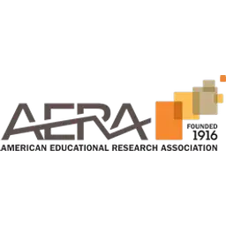
Araneda, S., Silva, M. & Varas, L. (2020, Apr 17 - 21) Improving equity in university admission through a class rank measure: Easier said than done [Poster Session]. American Educational Research Association Annual Meeting, San Francisco (Conference Canceled). http://tinyurl.com/wvpvjzq | 

Social Media & Other Virtual Venues

Individual Presentations

Araneda, S. (2024, August) Securing Tests with AI: Initial Explorations in Item Generation. [Virtual] Artificial Intelligence in Educational Measurement SIGIMIE, NCME. https://youtu.be/eH-QbBkeYQo | 
Araneda, S. (2021, June) An Experiential approach to test design and validation [Paper presentation]. Edmund Gordon Centennial Celebration: Sustaining Diversity, Culture, and Identity in Pedagogies and Assessments [Virtual]. | 

Organized Webinars

Araneda, S., Gándara, F., Santelices, V., Torres-Iribarra, D., Zunino, V. (2021, May) Pruebas Estandarizadas y Sistemas de evaluación de aprendizajes en Chile durante y post pandemia. [Virtual] Nexos Chile-USA & FEVED. https://www.youtube.com/watch?v=4rYXu75fn-k&t=3944s | 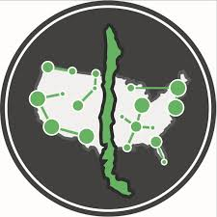

Organized Webinar Series

Webinars Validez, Fall 2024 – Spring 2025  Foro Chileno de Profesionales en Evaluacion Educacional FEVED  This series covered interviews with different Spanish-speaker experts in Educational Assessment about the concept of Validity. The series is published on my personal Youtube Channel https://www.youtube.com/@elsheshin | 
NCME GSIC Standards Study Group, Fall 2021, Spring 2022 and Summer 2022  Graduate Student Issues Committee at NCME  This series covered discussion sessions between students and Q&A with experts about each of the chapters in the Standards for Educational and Psychological Measurement. This series can be found at the NCME website and youtube channel https://www.ncme.org/students/student-programs/standards-study-group | 
Entrevistas FEVED, Spring 2022  Foro Chileno de Profesionales en Evaluacion Educacional FEVED  This series covered interviews with different experts in Educational Assessment in Chile. The series is published on the FEVED Youtube Channel https://www.youtube.com/@feved-forochilenoevaluacion | 

